|  |  |  |
| --- | --- | --- |
| ­­­Platinum Analytics -Player Tracking & Performance Analytics | | |
| Peter Collins | C10315971 | Bianca Schoen Phelan |

# Introduction & Project Statement

The goal of this report is to provide an overview of the aim and scope of this project. The report will comprise of the following sections.

* Background Research & Existing Solutions
* Technology Researched
* Analysis: Overview of System Functionality
* Design Process
* System Architecture
* Current Development
* Issues, Challenges & Future Work

## Project Objectives

The aim of this project is to create a tracking and performance analytics system for sports players using Bluetooth Sensors and Mobile Phones. The system will be capable of tracking a player's position, velocity and acceleration in close to real-time. With these properties and information about the player supplied, the system will be able to provide detailed information about a player's performance. This information will then be made available through a web application.

# What research has been done and what are the outputs?

## Background research

The field of sports analytics has become more popular in recent years with the advent of cheaper sensors which are light enough to be carried by players.

## Alternative existing solutions to the problem you are solving

|  |  |  |  |  |  |  |
| --- | --- | --- | --- | --- | --- | --- |
|  |  |  |  |  |  |  |
|  |  |  |  |  |  |  |
|  |  |  |  |  |  |  |
|  |  |  |  |  |  |  |
|  |  |  |  |  |  |  |
|  |  |  |  |  |  |  |

Due to the relative cheapness of sensor hardware, a number of companies offer solutions to the given problem. In the following table is a comparison of some of the leading brands and how my solution compares.

**Alternatives Comparison Table**

One of the core differences between my project and the leading brands is the chosen network protocol. I chose to use Bluetooth for my network protocol using mobile phones for the sensor receivers. This allowed me to collect sensor data in real-time without the need for expensive, proprietary hardware.

**Advantages of My Solution**

This project aims to provide amateur athelets access to a sports analytics platform for a much lower price than professional alternatives. This is accomplished by utilizing the abilities of commonly held, BLE4 and internet enabled smartphones. By using mobile phones to communicate with sensors the need for expensive proprioty receivers and base stations is surpassed.

## Technologies researched

What candidate technologies did you examine? What criteria did you use for selection? What experience you have in the chosen technologies? If new to you, what have you done to familiarise yourself with the new technology?

## Sensors

The Texas Instruments SensorTag was the chosen sensor for this project. The SensorTag has a number of different sensors on it. It also has the ability to communicate over Bluetooth.

## Receivers

## Back-end Application & Database Server

I decided to build a Rest API using Django Rest Framework to control all data required by the system. Django Rest Framework also allows you to define your database structure in Python code. It also provides a Web-

## Front-end Web Interface

## Other relevant research done

e.g. interviews/ surveys

## Resultant findings/requirements

For example, a list of requirements for your solution – based on your research and analysis

The hardware requirements for this project are as follows:

* Bluetooth Sensor
* Android Mobile Phone
* Linux Server

## Bibliography (research sources)

# Analysis: Describe clearly what your solution will do

# Approach and Methodology

The chosen software methodology for this project is Agile System Development Life Cycle (SDLC). The SDLC model is a combination of the iterative and incremental models which allow for the rapid delivery of software products. (1) The project is broken up into small incremental builds which are provided in iterations. In each iteration planning, analysis, design and testing are all performed. At the end of an iteration the chosen piece of the project is delivered in a fully working and tested order.

The SDLC model comprises of six phases: Concept, Inception, Construction, Transition/Release, Production and retirement.(2)

**Concept - Pre Planning**

The concept phase is performed at the very beginning of the project. In this phase information is gathered on the area of interest to help identify and clarify the scope of the project and the goals of the project are loosely defined. Also in this phase, a small amount of feasibility analysis is performed to determine if the project is worth investing time and money into.

**Inception - Project Initiation**

The goal of this phase is to initiate the project. This is achieved by:

* Defining the scope of the system in terms of high level use cases
* Deciding upon an initial architecture for the system
* Choose a language and platform for the system
* Setting up the development environment (choosing an OS, IDE)
* Define initial requirements

Based on the initial requirements, project scope and initial architecture it should now be possible to give a rough estimate of time required for the project. This estimate will evolve as the project continues.

**Construction**

The construction phase of the project is when all of the development is performed. The project is broken down into different sections which are separated by individual requirements. These requirements are then organized by priority and development work is carried in order of the highest to lowest priorities. Each set of requirements is completed in a chosen timeframe called a Sprint. A Sprint can be any amount of time but usually ranges between one week to one month. In a Sprint all the designing, developing and testing is performed for the chosen requirements. The developers meet up for Daily Scrum Meetings where they share their progress and identify potential issues. By having daily meetings, the project leader can see whether the project is on track and identify, right away, any problems which may derail the project or extend estimates.

Once the Sprint is completed the working piece of software is delivered to the customer. Development can now begin on the next set of requirements while the recently finished requirements can be tested by the customer in parallel. Any changes which the customer requires can now be added to the list of requirements with a priority level. This allows for the customer to ask for drastic changes early on in the life cycle should they identify a major flaw or problem with the delivered product.

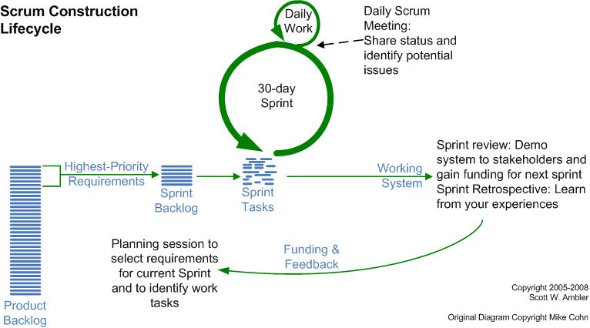

**Transition - Release**

In this phase of the project the final deployment of the product is carried out. Before the product is released one final round of testing is carried out. At this point most flaws should already be identified and fixed, so this round of testing is to make sure the product acts as the end users perceive it should. Hence a beta may be released or the product may be tested with a subset of the end users. Once the system is tested with these users it may be deployed.

**Production**

The goal of this phase is to keep the product useful, functional and productive after it has been deployed. Once the system is kept running and users use and know how to use the system the goal of this phase has been completed. This phase continues until the decision has been made to retire the product.

**Retirement**

The final phase of the Agile SDLC methodology is the retirement phase. This phase may be reached should the system become redundant or obsolete, get replaced, be no longer needed or should a newer version be released.

# Design

This chapter will cover the initial design elements of the system and it's architecture. These designs may be subject to change as the projects grows and evolves.

## Architecture Design

This system uses a Three-Tier Architecture comprising of a Presentation Tier, Middle Tier and Data Tier. Three-tier is a client-server architecture pattern in which the user interface, business/functional logic and data storage are developed as individual modules on separate platforms. (3) This modular application makes it possible to replace, update or upgrade any tier independently of the other tiers.

**Presentation Tier - The Client**

This is the User Interface for the system and in a web application it is usually the client's web browser. This is the tier from which the user interacts with the system. The user may view content, log in, request files or data and fill in forms. All of these request are sent to and handled by the Middle Tier.

**Middle Tier - Application Server**

This tier handles all of the logic and controls the functionality of the system. Any request from the user are processed here with validation and authentication being performed. Requests for data are taken from the user are received here, sent to the data tier and the response generated and returned to the user. This tier is sometimes referred to as middleware.

**Data Tier - Database Server**

This tier is concerned with the maintaining and serving of all data required by the system. The data may be stored in a shared folder but is more commonly stored in a database, especially for web applications. This tier usually provides a means of exposing the data to the Application server as well as a way to manage it which may be done by making an API available.

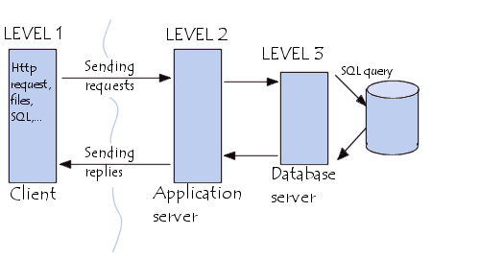

## Technical Architecture

The system comprises of two separate entities, each with

## Initial Use Cases

|  |
| --- |
| **Name:** Register a User |
| **Basic Course of Action:**   * User connects to website * User enters name and password * User verifies password * System validates input * System checks if user already exists in database * System saves user in database if data is valid and user does not already exist |

|  |
| --- |
| **Name:** Log in to App |
| **Basic Course of Action:**   * User opens app * User inputs name and password * System checks details against database * If user exists and password is correct, system takes user to home screen * If user does not exist or password is incorrect, the user is not authenticated and is given a message as to why not. |

|  |
| --- |
| **Name:** Register a Sensor in App |
| **Basic Course of Action:**   * User powers on sensor * User logs in to app * User selects Register a Sensor * System turns on phone's Bluetooth Connection * System searches for sensor * System asks user to confirm connecting to sensor * If confirmed system connects to sensor * User inputs name for sensor * User selects save * System posts sensor name to database * Database saves sensor name & associates user with sensor |

|  |
| --- |
| **Name:** Add a Receiver in App |
| **Basic Course of Action:**   * User powers on a receiver * User logs in to app * User selects Register a Receiver * System turns on phone's Bluetooth Connection * System searches for receiver * System ask user to confirm connecting to receiver * System asks user to give receiver an ID * System explains to user where the location of the sensors should be for Data Collection |

|  |
| --- |
| **Name:** Set up system for Data Collection |
| **Basic Course of Action:**   * User logs in to app * User selects a sensor * The system verifies the connection between the sensor and the app * If the sensor is found the user is taken to the Data Collection Screen * If the sensor is not found the user is redirected to the Register A Sensor Screen * The system verifies the connection between the other 2 receivers and the app * If the receiver is not found the user is taken to the Add A Receiver Screen * Once both receivers are verified as connected, the user may continue * The system asks the user which sport is being played * The system asks the user to place the sensors in the required locations * The system asks the user to name the current data collection * Once the system is set up with the sensors in place the user selects Begin Collection * The system will create a new DataCollection object in the database containing the ChosenSport, a TimeStamp and the DataCollection name. * The system will now move on to the data collection stage |

|  |
| --- |
| **Name:** Data Collection |
| **Basic Course of Action:**   * The system collects the RSSI and Accelerometer X, Y and Z values from the sensor * The system collects the RSSI values from the 2 receivers * The system creates a Sensor Reading containing Sensor_ID, Acc_x, Acc_y, Acc_z, RSSI_1, RSSI_2, RSSI_3 and a Timestamp * The system posts the Sensor Reading to the database * The system then takes the next set of values and repeats the process * The system stops data collection when the user selects End Collection |

|  |
| --- |
| **Name:** Data Processing |
| **Basic Course of Action:**   * For each reading the database receives * The system converts RSSI values into meters * The system finds the sensor's x and y values using a given formula * The system saves the sensor reading |

|  |
| --- |
| **Name:** View Collected Data |
| **Basic Course of Action:**   * The user logs in to the web application * The user navigates to the Data page * If there is no data currently being collected the page will notify the user and display link to display older data collections * If there is live data the system will display a link to the Live Data * The user selects Live Data * The live data which will be displayed on the screen will be the player's position on the pitch, the player's velocity and the G-Forces experienced. * The player's position will be overlaid on an image of the chosen sport * Graphs on the page will show running values for the other variables |

ERDs/ Class diagrams

# Prototyping and Development

Explain exactly what prototyping and development you have completed

# Testing

Explain your planned testing approach: For example: who will be involved, what test scripts are planned, how will the testing be executed.

# Issues and risks

Explain the main issues / challenges that are unresolved on your project. – and your suggested approach to solving them. This is a critical part of your report to show that you understand what is required to complete the project.

# Plan and future work

What are the key deliverables and date for the remainder of the project?

# Conclusions

Identify interim conclusions viz. summary of findings thus far, plausibility of the proposed system and personal development conclusions.